**September 2022**

**Food Allergies and Intolerances**

Food allergies are increasing at alarming rates. In fact, one in every 13 children has a food allergy—which is about two per U.S. classroom!

If you have children in your program with food allergies or intolerances, you know how important it is to prepare and serve safe meals. Having a plan and being prepared will help make sure children feel included and can safely join in meals. Knowing common allergens, reading food labels, and avoiding cross-contact will help prevent an allergic reaction and keep children safe.

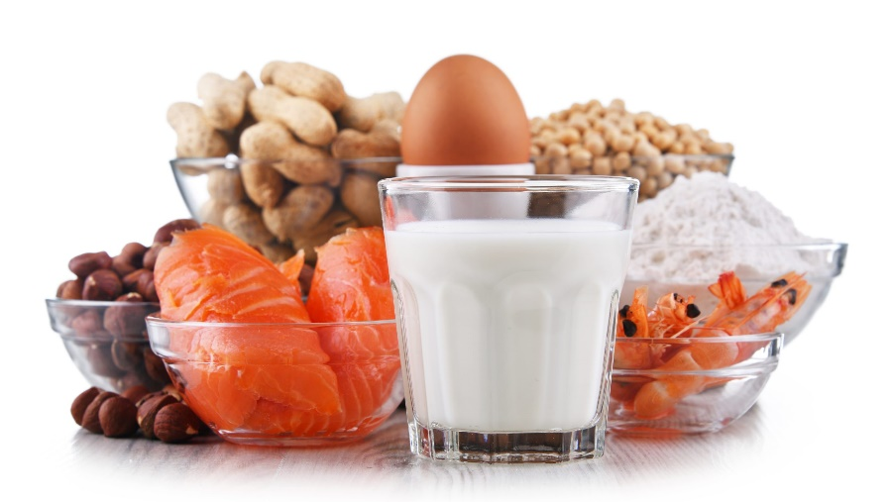



**Food Allergy versus Food Intolerance**

People often confuse food allergies and food intolerances. It is important to know the difference.

* A **food allergy** happens when the body’s immune system reacts to a protein in food. The food that causes the reaction is called an allergen. Symptoms of food allergies range from mild to life-threatening and are listed below.
* A **food intolerance**, or a food sensitivity, is when a person has a hard time breaking down a certain food. While food intolerances can cause gas, bloating, diarrhea, or upset stomach, they are not life-threatening.

**Symptoms of an Allergic Reaction to Food**

After eating a food with an allergen, mild or severe symptoms can appear within minutes or up to a few hours. They may be mild or severe and may include hives, nausea, vomiting, stomach pain, nasal congestion, runny nose, or swelling of the lips, tongue, or throat.

Anaphylaxis is a serious allergic reaction that may include difficulty breathing, dizziness, a drop in blood pressure, or loss of consciousness. If you suspect an anaphylactic reaction, call 911, and treat the child with an epinephrine auto-injector like Epi-Pen® right away.

Very young children may not know when they are having an allergic reaction, but may be able to tell you how they are feeling. Children may say one of the statements below when having an allergic reaction.

* My tongue (or mouth) is hot, burning, tingling, or itches.
* It feels like something is poking my tongue.
* My mouth feels funny.
* There’s something stuck in my throat.
* My lips feel tight.
* My throat feels thick.

A child may also show nonverbal signs of an allergic reaction, including:

* Putting their hands in their mouth
* Pulling or scratching at their tongue
* Slurring their words
* Their voice may change (become hoarse or squeaky)



Refer to the child’s allergy care plan from the family for steps to follow in case of an allergic reaction. Talk with the child’s family about the foods eaten and the child’s symptoms. Closely observe the child in case the reaction gets worse.

**Most Common Food Allergens**

While over 170 foods can cause an allergic reaction, nine major food allergens make up over 90% of food allergic reactions in the U.S. They are listed in the table below, with examples and possible food sources.

| **Allergen** | **Foods Containing the Allergen** | **Other Possible Sources of the Allergen** |
| --- | --- | --- |
| **Eggs** | Eggs (dried, powdered, solids, white, yolk) | Baked goods, breaded items, fried rice, mayonnaise, meatballs, meatloaf, pasta, surimi |
| **Fish** | Finfish (cod, haddock, halibut, salmon, tilapia, tuna), fish sticks | Barbecue sauce, bouillabaisse, salad dressing, surimi, Worcestershire sauce |
| **Milk** | Buttermilk or milk (condensed, evaporated, low-fat, nonfat, whole), butter, cheese, cottage cheese, cream, ghee, whey, yogurt | Baked goods, breakfast foods (cereals, pancakes, waffles), lunch meat, hot dogs, margarine, meatballs, nondairy products |
| **Peanuts** | Peanuts, peanut butter, peanut flour, mixed nuts | Baked goods, cereal (granola, muesli), chili, marzipan, pancakes, trail mix, sauces (chili sauce, hot sauce, pesto, gravy, mole sauce), salad dressing, certain cuisines [Mexican, African, Asian (especially Chinese, Indian, Indonesian, Thai, and Vietnamese)] |
| **Sesame** | Sesame (flour, oil, paste, salt, seed), tahini  Sesame may be listed under “spices” on a food label | Asian cuisine, baked goods, bread crumbs, cereals (granola, muesli), crackers, dressings, gravy, hummus, marinades, margarine, processed meats and sausages, sauces, soups, sushi, tempeh |
| **Shellfish** | Crustacean shellfish (crab, crawfish, lobster, prawns, shrimp) | Bouillabaisse, fish stock, seafood flavoring (crab or clam extract), surimi |
| **Soy** | Edamame, miso, soy (soy cheese, soy fiber, soy flour, soy grits, soy milk, soy nuts, soy sprouts, soy yogurt), soybeans, soy sauce, tempeh, tofu | Asian food, baked goods, dressings, grains prepared with soy (cereal, bread, chips, crackers, pasta, rice, tortillas), infant formula, processed and canned foods, sauces |
| **Tree Nuts** | Almonds, cashews, hazelnuts, marzipan (almond paste), mixed nuts, nut butters, pecans, pesto, pistachios, praline, trail mix, walnuts | Baked goods, barbeque sauce, cereal, cookies, crackers, marinade, certain cuisines (Chinese, African, Indian, Thai, Vietnamese) |
| **Wheat** | Wheat flour (all-purpose, enriched, whole wheat), bran, bulgur, durum, farina, germ, semolina, most bread products (bread crumbs, cereal, crackers, pasta, rolls) | Bread products using alternate grains, couscous, oats, salad dressings, sauces, soups, soy sauce, surimi |



For more information, resources, and videos on the nine major allergens refer to the following:

* Food Allergy Research & Education (FARE): [Common Allergens](https://www.foodallergy.org/living-food-allergies/food-allergy-essentials/common-allergens)
* Institute of Child Nutrition (ICN): [Child Care Center Food Allergy Fact Sheets](https://theicn.org/icn-resources-a-z/child-care-center-food-allergy-fact-sheets)

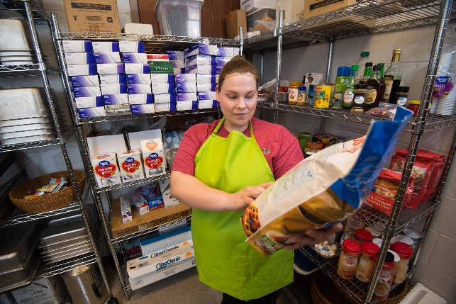

**Reading Food Labels**

One way to avoid an allergic reaction is to read food labels. The current eight major food allergens must be listed in plain language on the ingredients label: eggs, fish, milk, peanuts, tree nuts, shellfish, soy, and wheat. Starting January 1, 2023, sesame must be labeled as an allergen on packaged foods. Contact the food manufacturer if there is any question about a food containing an allergen.

* Watch for substitutions in your food deliveries. The replaced food might have an allergen not found in the product you usually buy.

*Labeling Allergens*

Allergens are included on food packages in one of three ways:

1. In the ingredients list, using the allergen’s **common or usual name** (ex., “whole wheat flour”)
2. In the ingredients list in **parentheses** after the ingredient that is not the common name (ex., “albumin (egg)”)
3. Listed after the ingredients list in a **“Contains” statement**(ex., “Contains milk and tree nuts”)

Labeling Allergens

**Example 1:**Ingredients: Whole wheat flour, enriched wheat flour, honey, soy.

**Example 2:**Ingredients: Whey protein (milk), lecithin (soy), albumin (egg), salt.

**Example 3:**Ingredients: Whole grain wheat, honey, natural almond flavor.  
**CONTAINS WHEAT AND ALMOND**

*Advisory Statements*

Advisory statements for allergens are located after the ingredients list and vary by product. Some common types of advisory statements include:

* “May contain…”
* “Made on equipment…”
* “Processed or manufactured in a facility that also processes…”

Do not serve these products to a child with a specified food allergy. Even if a food has a small amount of the allergen, it could cause a reaction.

Advisory Statements

**Example 1:**Ingredients: Whey protein, lecithin, salt.  
**Contains milk and soy. May contain traces of tree nuts.**

**Example 2:**Ingredients: Sunflower seed, sugar, salt.  
**Made on equipment that processes peanuts.**

**Example 3:**Ingredients: Sunflower seed, honey, salt.  
**Manufactured in a facility that also processes peanuts.**



For more information on reading food labels, refer to FARE’s [How to Read a Food Label](https://www.foodallergy.org/resources/how-read-food-label) webpage.

**Avoid Cross-Contact**

Another way to prevent an allergic reaction is to avoid cross-contact. Cross-contact happens when food that has an allergen touches another food or surface that does not have the allergen.

* For example, a knife used to spread peanut butter is then used to cut a turkey sandwich without cleaning in between. Peanut allergens will get onto the turkey sandwich, making it unsafe for a child with a peanut allergy to eat.

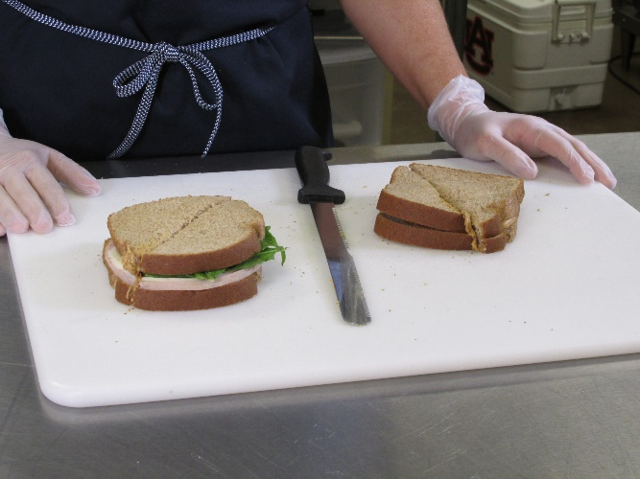

**Tips to Avoid Cross-Contact**

* Wash the following with soap, hot water, and friction:
  + Utensils, cutting boards, dishes, pots, and pans
  + Counters and tables
  + Hands (sanitizing gels or water alone will not remove an allergen)
* Cook or prepare the allergen-free foods first.
* Wrap, label, and separate allergen-free foods from those with allergens.
* Select an area in the kitchen for allergen-free meals, and use separate (or color-coded) equipment and utensils during preparation, cooking, and serving.
* If an allergen accidentally gets into a dish, do not serve it to a child with a food allergy.
* Teach children not to share food, drinks, or utensils.

